Bow River Microbiome – Alpha Diversity

Plotting observed richness against number of reads:

There is no relationship between the bacterial species richness and the total reads. This is unusual (usually positively correlated) but might be because it only takes a certain amount of reads to capture all the unique bacteria so past this point there is no increase? Looks like there is a positive correlation until about 50,000 reads so maybe past this point there is no increase in richness.

Could also be that either contamination or sequencing errors are causing there to be really low amount of richness even though there are a large amount of reads? I’m not sure why there are some very high reads that have very low richness…

**Rarefied alpha diversity:**

All samples combined.

**Figure 1:** Observed richness, Shannon, and Simpson diversity of rarefied bacterial sequences within macroinvertebrate and spider samples at each sampling site.

**Kruskal-Wallis test results:**

Significant differences in bacterial richness/diversity between:

|  |  |  |
| --- | --- | --- |
| *Observed Richness* | *Shannon Diversity* | *Simpson Diversity* |
| BRR2 – Cochrane, p=0.008 | BRR2 – Cochrane, p=0.03 | BRR2 – Sunalta, p=0.028 |
| BRR2 – Sunalta, p=0.0059 | BRR2 – Sunalta, p=0.019 | BRR2 - Cushing Bridge, p=0.025 |
| BRR2 - Cushing Bridge, p=0.0044 | Cochrane - Cushing Bridge, p=0.012 | BRR2 – Cochrane, p=0.047 |

Separated by insects and spiders.

All spiders:

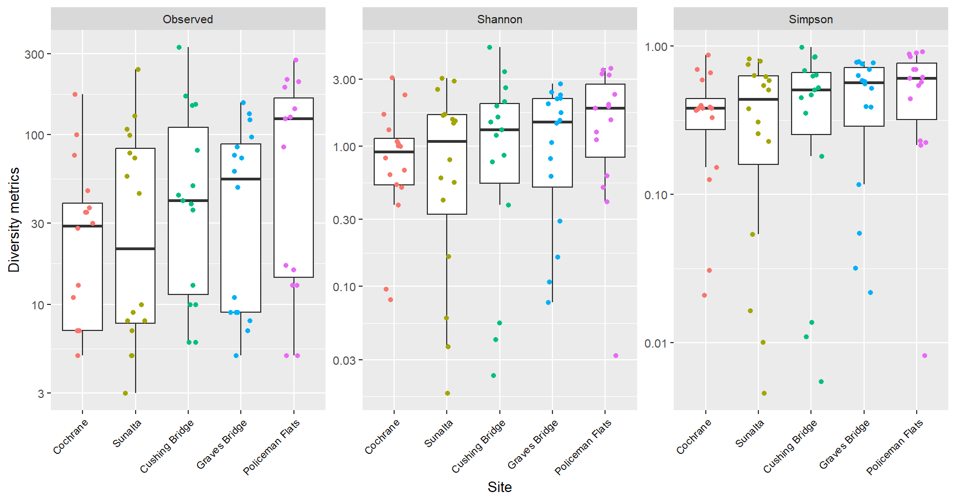

**Figure 2:** Observed richness, Shannon, and Simpson diversity of bacteria within spider samples at each sampling site.

No significant differences in observed richness, Shannon diversity or Simpson diversity in spider samples across sampling sites. Alpha diversity and richness of spider microbiomes was not affected by wastewater effluent exposure.

All macroinvertebrates:

**Figure 3:** Observed richness, Shannon, and Simpson diversity of bacteria within macroinvertebrate samples at each sampling site.

Significant differences in observed richness of macroinvertebrate samples between BRR2 – Cochrane and BRR2 – Cushing Bridge

Significant differences in Shannon diversity and Simpson diversity of macroinvertebrate samples between BRR2 – Cushing Bridge

Alpha diversity and richness of freshwater macroinvertebrate microbiomes was not affected by wastewater effluent exposure.

There was a significant difference in richness and both alpha diversity metrics between insects and spiders, with spiders having a lower alpha diversity and richness at each sampling site.

Spider: Macroinvertebrate:

Larval Hydropsychids:

**Figure 4:** Observed richness, Shannon, and Simpson diversity of larval Hydropsychidae microbiome samples at each sampling site.

Significant differences in observed richness between:

* #Policeman Flats - Sunalta p=0.0004
* #PCR1 - Sunalta p=0.0006
* #BRR2 - Sunalta p=0.045
* #Cushing Bridge - Policeman Flats p=0.008
* #Cochrane - Policeman Flats p=0.0026
* #Cushing Bridge - PCR1 p=0.012
* #Cochrane - PCR1 p=0.004
* The effluent impacted sites on the Bow River and the ACWA streams have higher observed richness.

Significant differences in Shannon diversity between:

* #Cochrane - Policeman Flats p=0.00065
* #Cushing Bridge - Policeman Flats p=0.0023
* #PCR1 - Sunalta p=0.026
* #Policeman Flats - Sunalta p=0.00023
* Effluent impacted sites on the Bow have higher Shannon diversity but no differences between ACWA streams

Significant differences in Simpson diversity between:

* #Cochrane - Policeman Flats p=0.006
* #Cushing Bridge - Policeman Flats p=0.006
* #Policeman Flats - Sunalta p=0.00076
* Policeman Flats had the highest Simpson index (lowest diversity). This doesn’t make sense with the previous Shannon diversity result…

Tricoptera (larvae and adults):

**Figure 5:** Observed richness, Shannon, and Simpson diversity of larval Hydropsychidae microbiome samples at each sampling site.

* How can sites have high inverse Simpson and Simpson values? Aren’t those inverse of eachother?
* Tricoptera have very variable alpha diversity/richness (some samples are very low while others are very high). Seems like similar trends as larval hydropsychids apply though.

Larval Heptageniidae:

**Figure 6:** Observed richness, Shannon, inverse Simpson, and Simpson diversity of larval Heptageniidae microbiome samples at each sampling site.

* Only sig difference is Simpson diversity between Cochrane and Policeman Flats
* Simpson and inverse Simpson give the same result.

Baetidae (larvae and adults at PCR1 PCR3 ACWA streams only):

**Figure 7:** Observed richness, Shannon, inverse Simpson, and Simpson diversity of larval and adult Baetidae microbiome samples at each sampling site.

* No differences in richness/diversity

All Ephemeroptera:

**Figure 8:** Observed richness, Shannon, inverse Simpson, and Simpson diversity of ephemeroptera microbiome samples at each sampling site.

* All Ephemeroptera (order level) is way more variable than family level in terms of richness and diversity especially at Cushing Bridge
* No differences in richness or diversity

Chironomidae:

**Figure 9:** Observed richness, Shannon, inverse Simpson, and Simpson diversity of larval and adult Chironomidae microbiome samples at each sampling site.

* No difference in richness or alpha diversity

Perlidae:

**Figure 10:** Observed richness, Shannon, inverse Simpson, and Simpson diversity of larval Perlidae microbiome samples at each sampling site.

* No difference in richness or alpha diversity

Araneidae:

**Figure 11:** Observed richness, Shannon, inverse Simpson, and Simpson diversity of Araneidae microbiome samples at each sampling site.

* Only difference in observed richness between Cochrane and Policeman Flats

Tetragnathidae:

**Figure 12:** Observed richness, Shannon, inverse Simpson, and Simpson diversity of Tetragnathidae microbiome samples at each sampling site.

* No differences in richness or alpha diversity
* High within site variability (intra variability)

*“From Joey711 GitHub: You* ***do not want to transform or filter your data before estimating richness****, other than quality assurance filtering that would remove non-target sequences. Usually that sort of filtering would be done on the sequence data before it is in the form of a contingency table (table of counts). Basically, the very first table of counts that you have in your workflow is probably the one that you want to use for estimate_richness and plot_richness. There are several different alpha diversity estimators supported in the estimate_richness function, and they all incorporate library size into their estimates in different ways... Except for the "Observed" option, which is simply showing you graphically the OTUs that were observed at least once in each sample. To be clear, the other methods require that you use raw counts.* ***Do not use rarefied counts for the Chao-I estimate, or the Shannon index, for example.*** *The "Observed" option is not a method at all, just showing you what is in your data as you provided. If you transform your data, especially if you rarefy, and then you want to estimate richness, the "Observed" result is now the only one still available to you at all.* ***Rarefying reduces the precision with which you would estimate the diversity in the first place, and so this generally shouldn't be done.*** *I suspect, however, that is the workflow you had in mind. All alpha-diversity indices/estimates are aware of differences in sample size (library size, number of reads in this case), because this has always been a problem when attempting to count things, even trees in a forest (see Sanders original paper describing rarefaction, a different technique than rarefying, if rarefying can be called a technique).”*

Non-rarefied alpha diversity:

All samples combined.

**Figure 1:** Observed richness, Shannon, and Simpson diversity of non-rarefied bacterial sequences within macroinvertebrate and spider samples at each sampling site.

Macroinvertebrate samples:

**Figure 2:** Observed richness, Shannon, and Simpson diversity of non-rarefied bacterial sequences within macroinvertebrate samples at each sampling site.

Significant differences in bacterial observed richness in macroinvertebrate non-rarefied samples between BRR2 – Sunalta, BRR2 – Cushing Bridge, BRR2 – Cochrane. Same results as the rarefied analysis.

Significant difference in bacterial Shannon diversity of non-rarefied macroinvertebrate samples between BRR2 – Cushing Bridge. Same as rarefied analysis.

No significant difference in Simpson diversity of non-rarefied macroinvertebrate samples. This was slightly different than the rarefied analysis which had BRR2 – Cushing Bridge different.

Overall, the non-rarefied vs rarefied analyses were very similar in their results for macroinvertebrate alpha diversity and richness. The same conclusion is reached that wastewater exposure does not have an influence on their microbiomes.

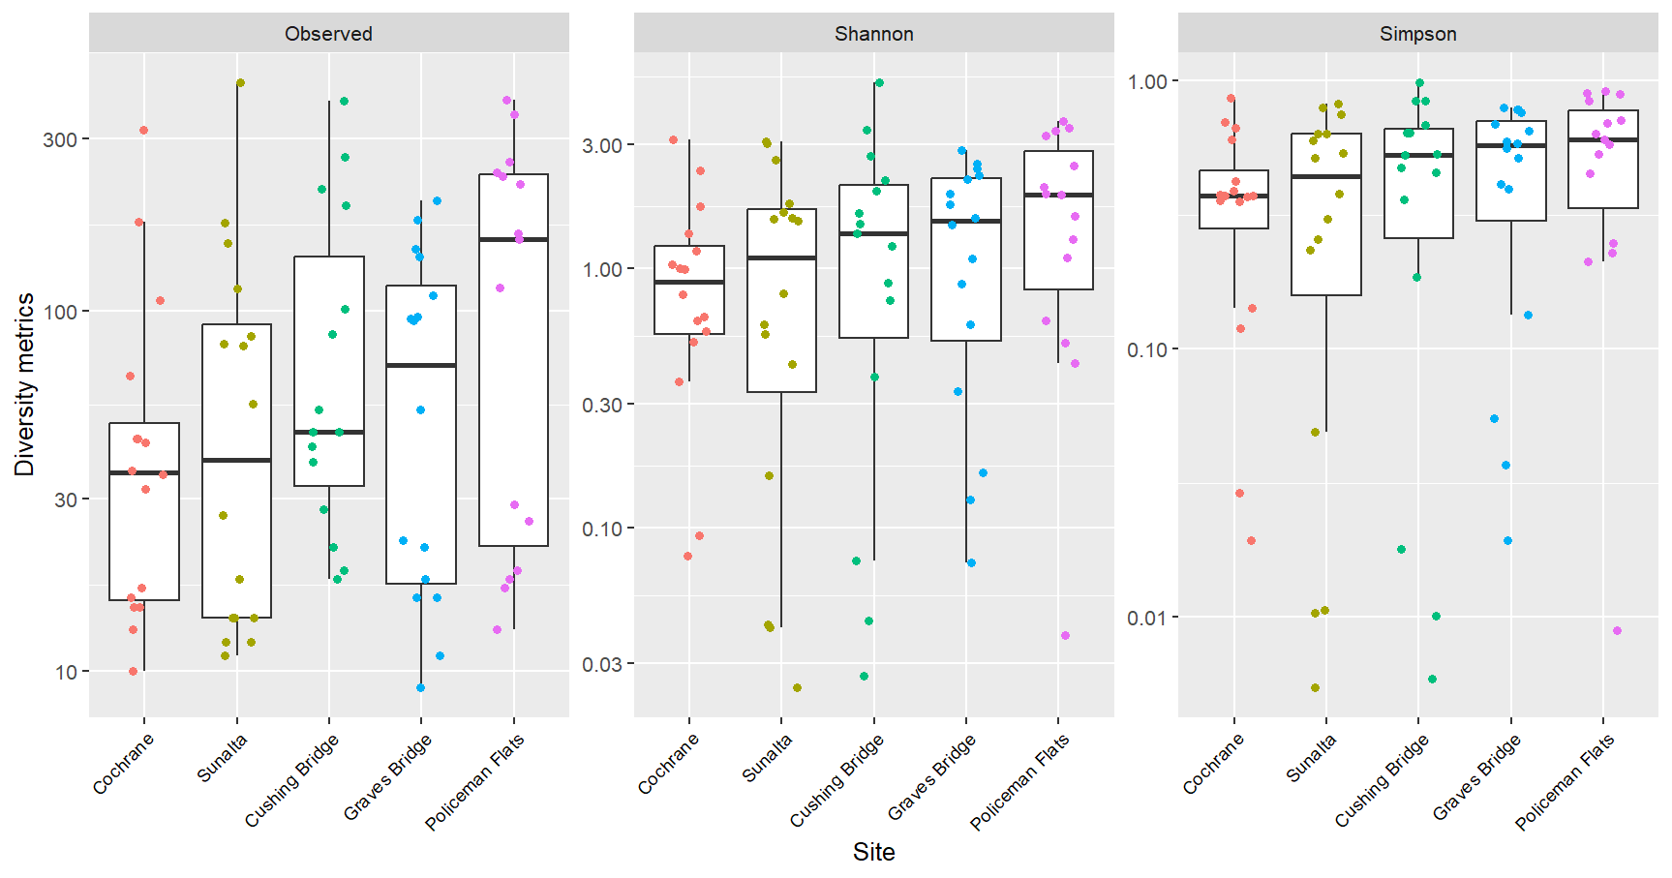Spider samples:

**Figure 3:** Observed richness, Shannon, and Simpson diversity of non-rarefied bacterial sequences within spider samples at each sampling site.

There were no significant differences in richness or alpha diversity measures of microbiomes in spider samples across sites. This was the same conclusion in the rarefied analysis. Indicates that wastewater is not influencing the microbiome of these organisms.

Overall, it does not matter too much for alpha diversity/richness whether the data was rarefied or not.